Final Exam
Psychology 206
Psychology of Music
Worth 50 Points
May 4th, 2017

Slayter Box: ______________________

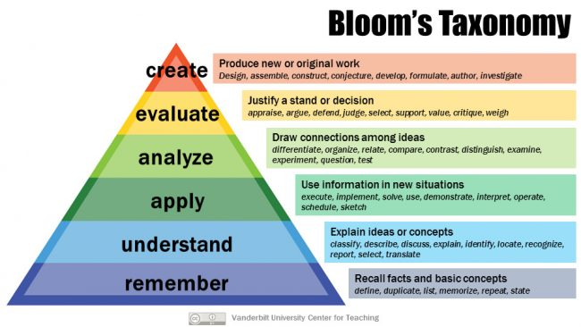

https://cft.vanderbilt.edu/guides-sub-pages/blooms-taxonomy/
Bloom’s Taxonomy: Understand
1. (5 points) According to Levitin’s chapter entitled “What is Music? From Pitch to Timbre”, briefly explain the psychological phenomenon called restoration of the missing fundamental.

Bloom’s Taxonomy: Understand
2. (5 points) According to Sacks’ chapter entitled, “An Auditory World: Music and Blindness”, briefly summarize the results of the study that addressed musical interest and ability in the case of children with SOD (Septo-Optic Dysplasia).

Bloom’s Taxonomy: Create
3. (5 points) Psychological scientists have investigated the ways and extent to which musical preferences reflect biological predispositions versus learned preferences. In the space below construct two graphs, side-by-side. The graph on the left should reflect empirically observed evidence from Psychological Science supporting the claim that musical preferences reflect biological predispositions. Label your axes. The graph on the right must have the same axis labels, but should reflect hypothetical data disconfirming the claim that biological predispositions reflect musical preferences. Specific numeric values don’t matter. I’m just looking for the patterns across your graphs.

Bloom’s Taxonomy: Apply
4. (5 points). Pick a principle from Gestalt Psychology and apply it to a novel (new) and specific musical example. Hint: Levitin’s chapter entitled, “Behind the Curtain: Music and the Mind Machine” might help.

Bloom’s Taxonomy: Understand
5. (5 points) Briefly explain the neurological basis of so-called phantom limbs. Hint: Recall Sacks’ chapter entitled, “Phantom Fingers: The Case of the One-Armed Pianist”.

Bloom’s Taxonomy: Create
6. (5 points) Construct a diagram of the stimuli that psychological scientists have used to evaluate subjective accenting.

Bloom’s Taxonomy: Evaluate
7. (5 points) Intuitively, one might construe Absolute Pitch as a wonderful “gift”. Critique this view by citing two pieces of evidence that absolute pitch generates challenges for those with this “gift”. Hint: Recall Sacks’ chapter entitled, “Papa Blows His Nose in G: Absolute Pitch”. Your response must reflect specific information in Sacks’ chapter.

Bloom’s Taxonomy: Create
8. (5 points) Create one scatter plot that shows the relationships among the following, according to Psychological Science: IQ Change; EEG (P2) Amplitude Change; Music Lessons; Visual-Art Lessons. Label all axes and relevant variables. There is no need for specific numeric values. I’m just looking for a graphical rendering of the critical patterns.

Bloom’s Taxonomy: Understand
9. (5 points) Briefly explain “spandrals”, according to Levitin’s chapter “The Music Instinct: Evolution’s #1 Hit”.

Bloom’s Taxonomy: Create
10. (5 points). Construct one graph that shows how music preferences compare to traditional zero-acquaintance-stimuli for accurately predicting each of the five personality traits indexed by the Big Five Inventory (BFI)? Your response should specify the comparison for each of the five.

Congratulations on completing the course, and thank you for a wonderful semester! Have a great summer!

